# Exercise: jQuery Plugins

Problems for exercises and homework for the ["JavaScript For Front-End Course@SoftUni"](https://softuni.bg/trainings/2032/javascript-for-front-end-july-2018#lesson-8965).

You are allowed to change the **HTML** and **CSS** in all exercises. Archive your solutions and upload them in [course page](https://softuni.bg/trainings/2032/javascript-for-front-end-july-2018#lesson-8969).

## Slick Slider

You are given the **HTML** and **CSS**. Your task is to implement the jQuery [Slick Slider](http://kenwheeler.github.io/slick/) plugin to solve the exercise.

Import plugin files into your project folders.

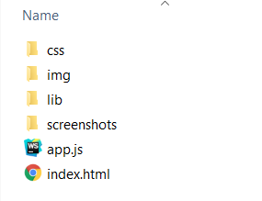

It comes together with the following **JavaScript** file:

|  |
| --- |
| app.js |
| ***// TODO: Implement plugin functionality*** |

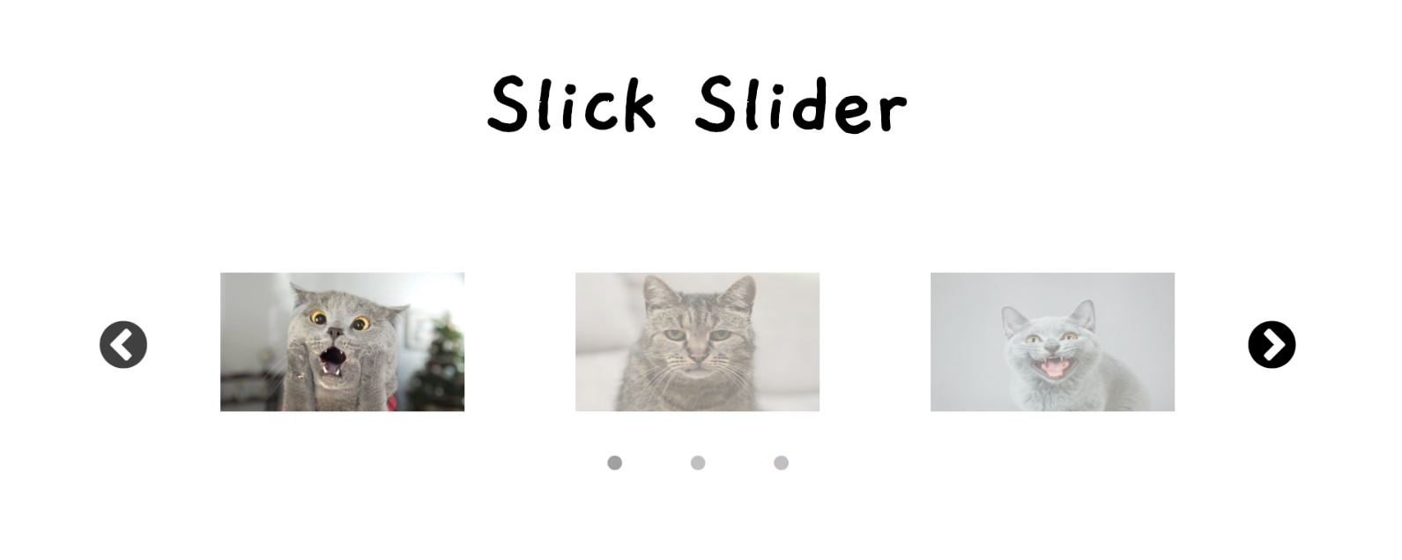

## Date & Time Picker

You are given the **HTML** and **CSS**. Your task is to implement the jQuery [Date & Time Picker](https://xdsoft.net/jqplugins/datetimepicker/) plugin to solve the exercise.

It comes together with the following **JavaScript** file:

|  |
| --- |
| app.js |
| ***// TODO: Implement plugin functionality*** |

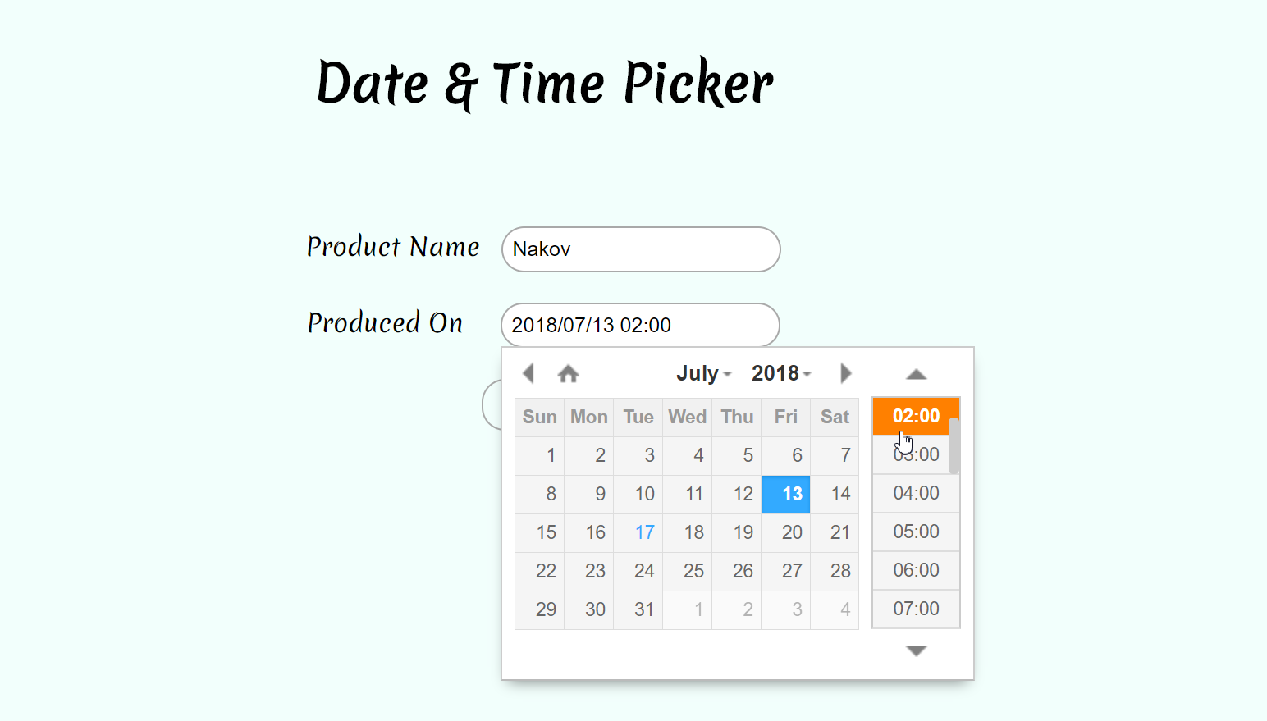

## Form Validator

You are given the **HTML** and **CSS**. Your task is to implement the jQuery [Form Validator](http://www.formvalidator.net/) plugin to solve the exercise.

It comes together with the following **JavaScript** file:

|  |
| --- |
| app.js |
| ***// TODO: Implement plugin functionality*** |

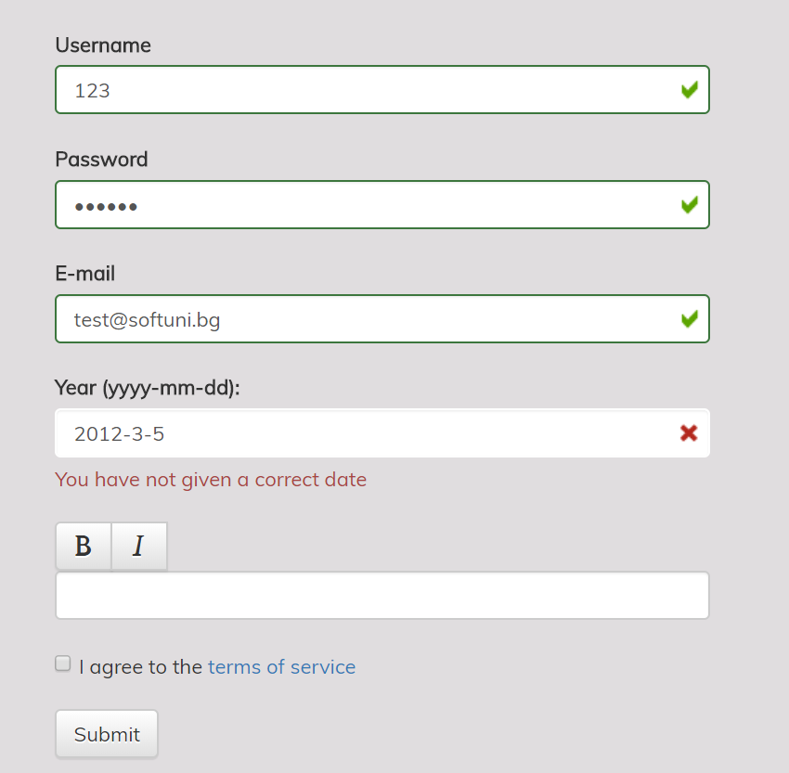 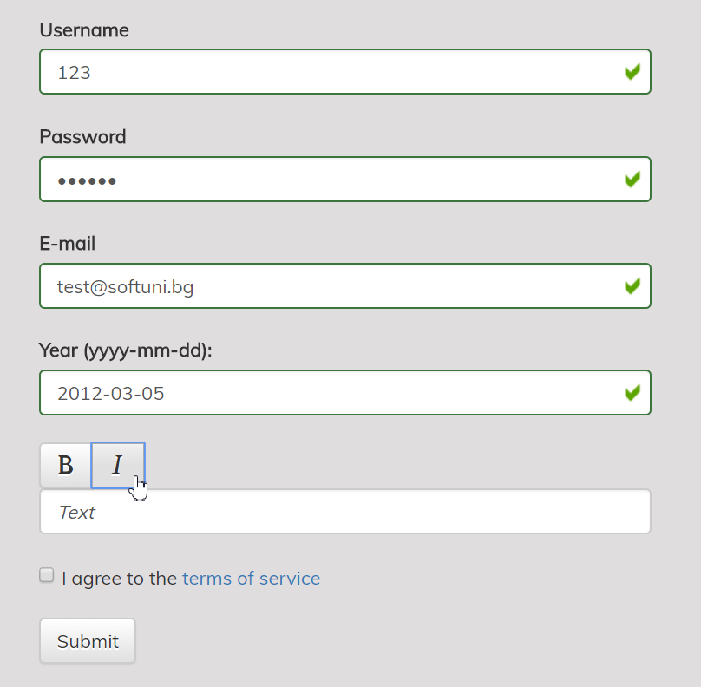

## Table Grid

You are given the **HTML** and **CSS**. Your task is to implement the jQuery [Table Grid](https://datatables.net/) plugin to solve the exercise.

It comes together with the following **JavaScript** file:

|  |
| --- |
| app.js |
| ***// TODO: Implement plugin functionality*** |

